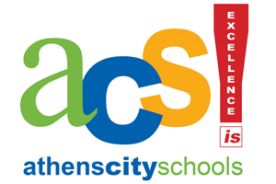
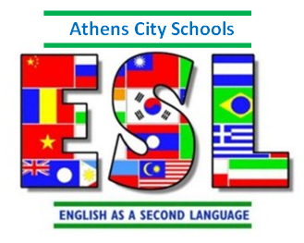
Athens City Schools
English as a Second Language Program
ESL Specialist: Beth Franks

ESL Progress Report

MARKING CODE
CD Consistently Displayed
P Developing/Progressing
N Not Yet Evident
X Not Assessed at This Time
Student’s Name _____________________________________

Grade ______ WIDA ACCESS/W-APT Proficiency Level: ______

Year 2015-2016 School CP IS WS NC ACMS
Marking Period
Goal 1: To use English to communicate in social settings |  | 1 | 2 | 3 | 4
Shares and requests information
Expresses needs, feelings, ideas
Engages in conversations and social exchanges
Listens to and imitates the way others use English
Describes favorite characters in stories
Indicates interests, opinions, or preferences

Goal 2: To use English to achieve academically in all content areas
Participates in group and paired discussions
Follows oral and written directions
Requests information, assistance, and clarifications
Connects new information to information previously learned
Elaborates and extends own ideas and that of others

Goal 3: To use English in socially and culturally appropriate ways
Observes and models others’ speech and behavior
Responds to and uses slang and idioms
Participates in activities of U.S. cultural heritage
First Quarter Comments: October  PARENT CONFERENCE (Yes / No) | Second Quarter Comments: December
Third Quarter Comments: March | Fourth Quarter Comments: May

